Section 1: Scope and Descriptive Statistics
Objective
The objective of this report is to analyze key performance data for Pastas R Us, Inc., focusing on whether the current expansion criteria and marketing strategies are effectively supporting profitability and growth. Using predictive and qualitative analysis, this report evaluates the relationship between demographic variables, loyalty card usage, and sales performance to provide actionable insights for executive decision-making.
Nature of the Data
The dataset includes information from 74 restaurant locations, measuring multiple operational and demographic variables. The primary variables analyzed include annual sales per square foot, median household income within a 3-mile radius, median age, percentage of residents with bachelor’s degrees, loyalty card usage percentage, and annual sales growth percentage. These variables allow the company to evaluate how local demographics and loyalty programs correlate with financial performance and store efficiency.
Descriptive Statistical Summary
Mean | 2580.47 | 7.12 | 14.82 | 1.81 | 385.12 | 67,636.61 | 35.61 | 25.04 | 1,033.87
Standard. Dev. | 372.38 | 0.33946992 | 3.708637514 | 0.760090135 | 96.37785183 | 14132.87643 | 4.16321762 | 6.367701237 | 276.6199362
Min | 1251.00 | 6.58 | 10.17 | 0.29 | 234.04 | 39,650.00 | 24.70 | 15.00 | 589.78
Q1 | 2400.00 | 6.805 | 11.62 | 1.13 | 328.51 | 60263.5 | 33.35 | 20 | 852.014
Median | 2500.00 | 6.95 | 12.80 | 1.98 | 361.14 | 67,925.00 | 35.60 | 25.00 | 986.81
Q3 | 2735.25 | 6.95 | 12.80 | 2.10 | 361.14 | 67,925.00 | 35.60 | 25.00 | 986.81
Max | 3799.00 | 7.97 | 28.81 | 3.38 | 551.58 | 92,602.00 | 43.50 | 40.00 | 1,730.53
Skew | 0.53 | 0.810779439 | 1.778922586 | -0.202324147 | 0.210228687 | -0.21043357 | -0.37289666 | 0.094085613 | 0.618151529
IQR | 335.25 | 0 | 0 | 0 | 0 | 0 | 0 | 0 | 0

35.61 | 25.04 | 1,033.87
4.16321762 | 6.367701237 | 276.6199362
24.70 | 15.00 | 589.78
33.35 | 20 | 852.014
35.60 | 25.00 | 986.81
35.60 | 25.00 | 986.81
43.50 | 40.00 | 1,730.53
-0.37289666 | 0.094085613 | 0.618151529
0 | 0 | 0
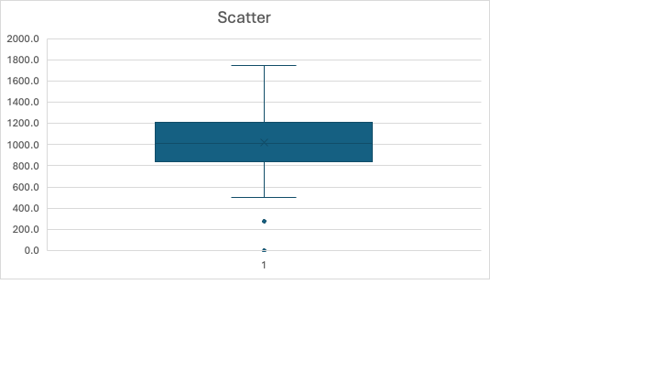

From the Week 1 analysis, the distribution of annual sales and sales per square foot showed noticeable right skewness, meaning a small number of top-performing restaurants are raising the overall average. The mean annual sales per square foot was approximately $385.12, while the median was lower, confirming the presence of outliers on the high end. The standard deviation of $96.38 indicates moderate variation in store performance. Median household income averaged around $67,637, suggesting locations were generally situated in above-average income areas. The median age of 35.6 years aligns with the target demographic of 25–45 years old, and the average loyalty card usage of 1.81% suggests limited adoption despite the marketing rollout.

Section 2: Analysis
Scatter Plot Interpretations
- Sales per Square Foot vs. bachelor’s Degrees (%)
The scatter plot for sales per square foot and bachelor’s degree percentage shows a slightly positive relationship. Locations with a higher percentage of college-educated residents tend to generate higher sales per square foot, suggesting an association between education level and purchasing behavior. This could indicate that more educated populations value the quality, health options, and brand positioning of Pastas R Us.
- Median Income vs. Sales per Square Foot
The relationship between median household income and sales per square foot appears weakly positive. While higher income areas do show slightly higher sales density, the correlation is not strong enough to justify income alone as a predictor. Other factors, such as local competition, visibility, and consumer habits, may influence these results.
- Median Age vs. Sales per Square Foot
The scatter plot shows a slight negative relationship between median age and sales per square foot. Younger communities (ages 25–40) appear to spend more per square foot than older populations. This suggests that Pastas R Us’ menu, price point, and atmosphere align better with younger, urban, and family-oriented consumers.
- Loyalty Card (%) vs. Sales Growth (%)
The relationship between loyalty card usage and sales growth is mildly positive. Locations with higher loyalty participation tend to experience slightly greater year-over-year sales growth. This correlation suggests the program may be working, but adoption rates are low enough that the impact is not yet maximized.

Section 3: Expansion Criteria
Pastas R Us currently bases expansion decisions on three demographic criteria:
- Median age between 25 and 45 years
- Median household income above the national average
- At least 15% of the adult population holding a college degree
These factors were selected to target markets with strong disposable income and customers who appreciate quick, healthy dining options. The analysis confirms these criteria generally align with higher-performing locations. However, the relationship between income and performance is weaker than expected, suggesting income alone should not weigh heavily in site selection.

Section 4: Recommendations and Implementation
Effective Expansion Criteria
The strongest predictor of sales performance appears to be education level, followed by median age. Locations with a higher percentage of college graduates and younger demographics tend to show stronger sales per square foot. Therefore, Pastas R Us should continue to prioritize areas with higher education concentrations and maintain the median age target. Median income can remain a secondary criterion but should not be the primary factor.

Loyalty Card Program Evaluation
The loyalty card shows potential but is underutilized. A stronger incentive structure—such as personalized offers, app integration, or a tiered reward system—could boost engagement. Data shows that as loyalty usage rises, so does sales growth, indicating the program’s value when actively used. Increasing visibility and digital accessibility could help drive consistent repeat visits.
Market Positioning Recommendation
The brand should continue to position itself toward younger, health-conscious professionals and families. The 25–40 age bracket aligns with both income and lifestyle patterns conducive to casual dining. Marketing should highlight convenience, fresh ingredients, and customization options, integrating local culture into branding. For example, regional menu variations or community-focused events can strengthen connection and loyalty in diverse local markets.
Data Collection for Ongoing Evaluation
To continuously monitor effectiveness, Pastas R Us should collect data on:
- Customer demographics via loyalty sign-ups
- Repeat customer frequency and average ticket size
- Digital engagement (mobile orders, online feedback)
- Local event participation and community engagement impact
The most efficient method is sampling through customer surveys and loyalty data analytics, as a full census is unnecessary for ongoing performance tracking. Survey results can be paired with store-level sales metrics to identify patterns between engagement and growth.

References

CareerFoundry. (2023). Predictive analytics in business decision-making. https://careerfoundry.com

Caltech. (2024). Data-driven strategies for business expansion and consumer analytics. Center for Data Science Research Publications.

University of Phoenix. (2025). Pasta R Us dataset and project scenario materials. BUS/475: Data Analytics for Managers.

